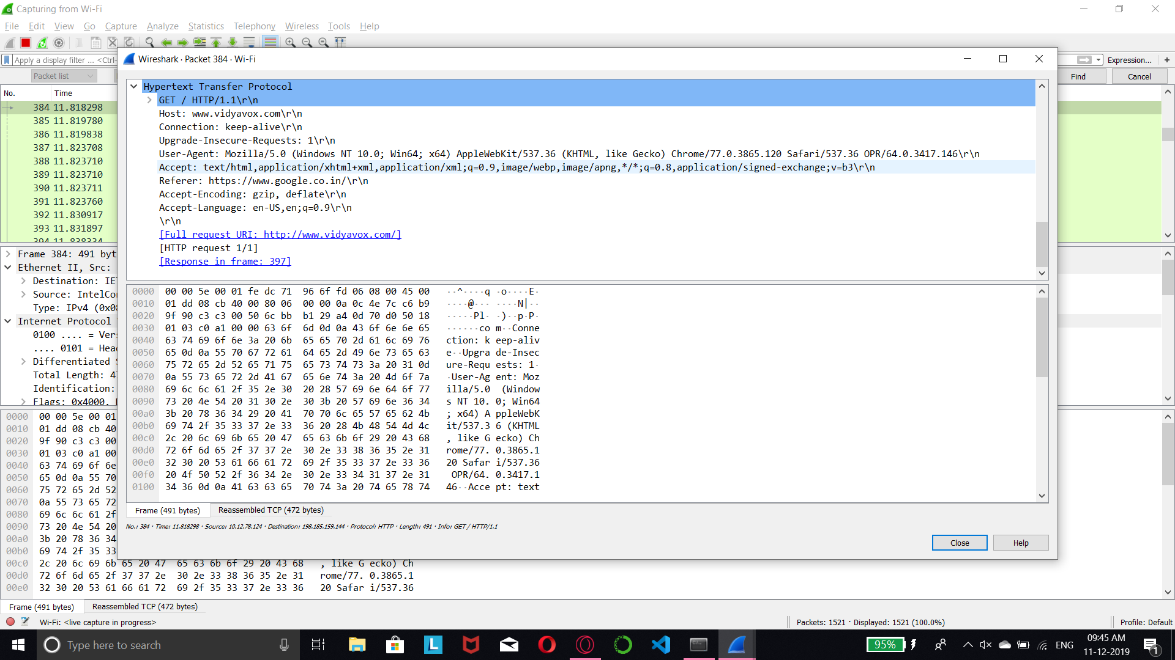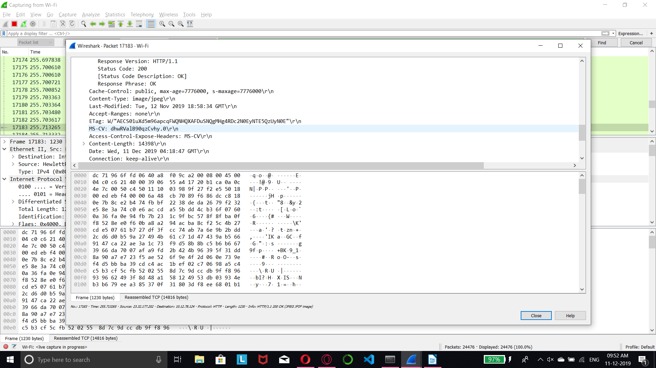1)

2) Source and Destination IP Addresses (IPv4)

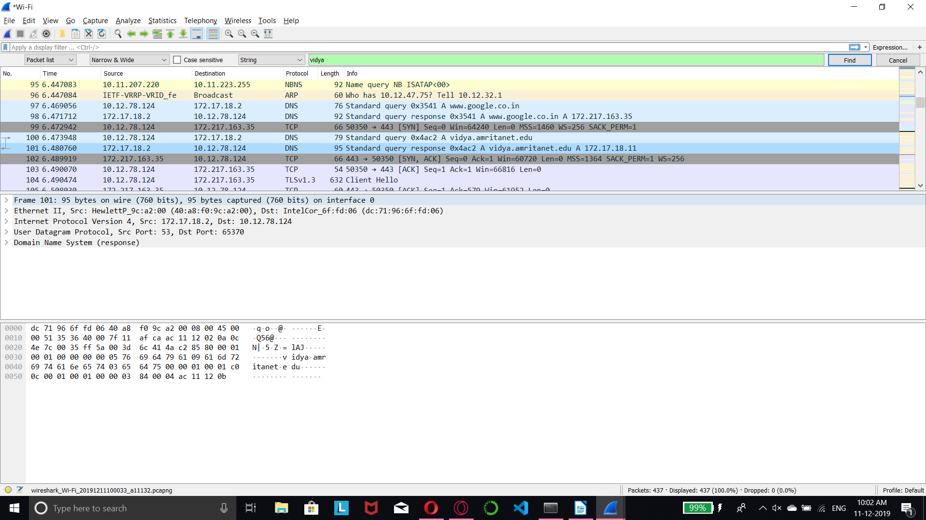

3)

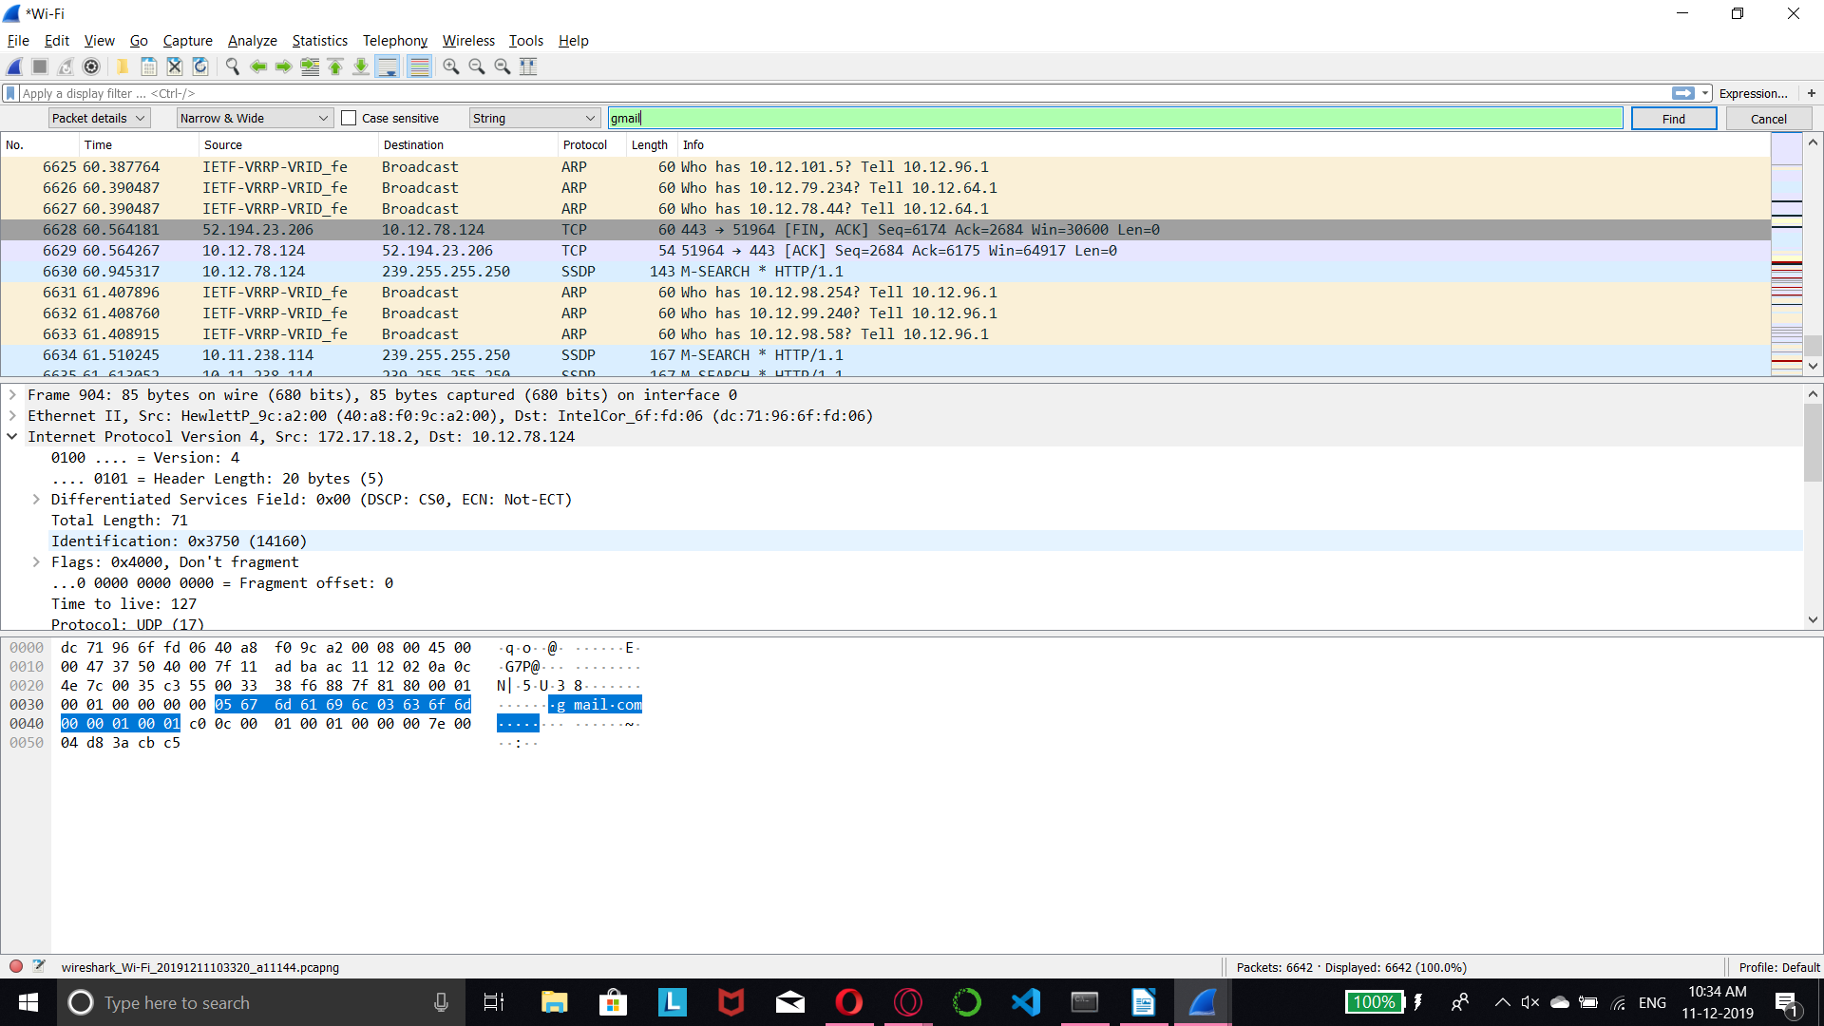

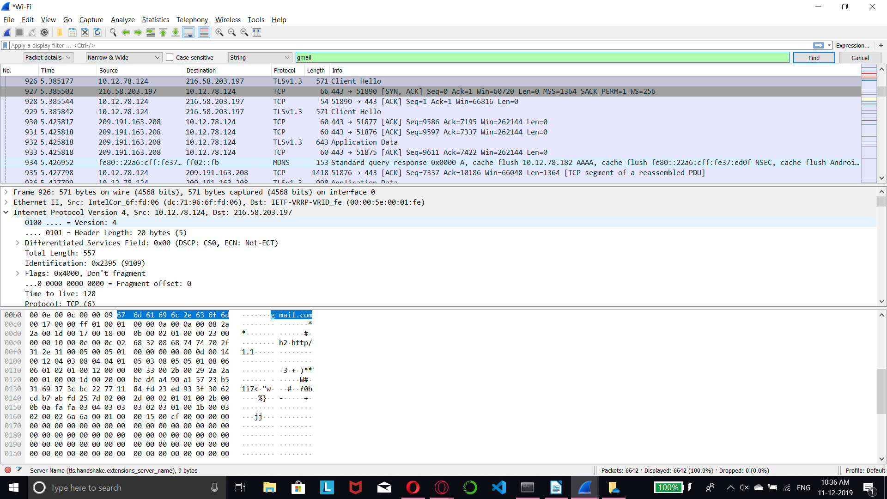

**Average requests sent = 926 – 904 = 22 + 1 = 23 requests**

**(Final Frame number – Initial Frame number, hence includes the number of requests sent)**

4)



5)

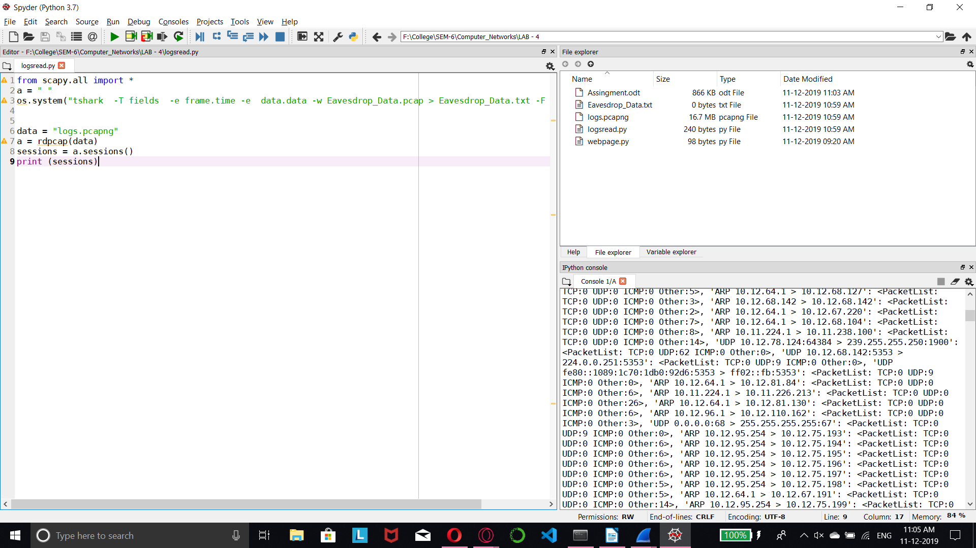

**from scapy.all import \***

**a = " "**

**os.system("tshark -T fields -e frame.time -e data.data -w Eavesdrop_Data.pcap > Eavesdrop_Data.txt -F pcap -c 1000")**

**data = "logs.pcapng"**

**a = rdpcap(data)**

**sessions = a.sessions()**

**print (sessions)**